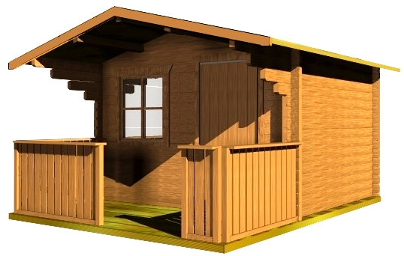

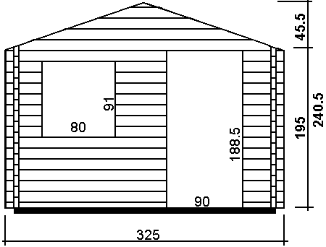
£1,519

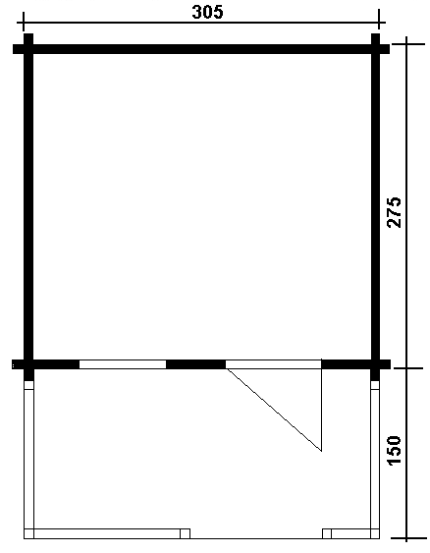
Consists of:

Walls: Sturdy 45 mm double tongue and groove wall boarding from northern fir.

Flooring: 20 mm tongue and groove floor boards on the impregnated fundament frame. Floor fringes.

Roof: 20 mm tongue and groove roof boards on the roof beams.
Overhanging canapy – 120 cm.
Roof coating is not included in the price.

Door: 1 unit 90/185. The doors could be fully glazed, glass on top half or without glass.

Windows: 1 tilt‘n‘turn unit 80/88.

